Annexure – 1

**SMALL QUIZZES WEBSITE**

***A Mini Project-I Report submitted***

***in partial fulfillment of the requirements***

***for the award of the degree of***

**BACHELOR OF TECHNOLOGY**

***In***

**COMPUTER SCIENCE & ENGINEERING**

***By***

1.19B01A05D5- P.V.L.SIREESHA 3.19B01A05I5 - V.VISHNU PRIYA

2. 19B01A05I0 - V.SWETHA 4.19B01A05F4 – P.HEMA

2. 18B01A0528 – K.SWETHA

***Under the esteemed guidance of***

**Ms R.V.SWATHI**



**DEPARTMENT OF COMPUTER SCIENCE & ENGINEERING**

**SHRI VISHNU ENGINEERING COLLEGE FOR WOMEN(A)**

**(Approved by AICTE, Accredited by NBA & NAAC, Affiliated to JNTU Kakinada)**

**BHIMAVARAM – 534 202**

**2020 – 2021**

Annexure – 2

**SHRI VISHNU ENGINEERING COLLEGE FOR WOMEN (A)**

**(Approved by AICTE, Accredited by NBA & NAAC, Affiliated to JNTU Kakinada)**

**BHIMAVARAM – 534 202**

**DEPARTMENT OF COMPUTER SCIENCE & ENGINEERING**



**CERTIFICATE**

*This is to certify that the Mini Project-I entitled “****Small quizzes website****”, is being submitted by* ***P.Vidya Lakshmi Sireesha*** *bearing* *the* ***Regd. No. 19B01A05D5***

*in partial fulfillment of the requirements for the award of the degree of “****Bachelor of Technology*** *in* ***Computer Science & Engineering****” is a record of bonafide work carried out by her under my guidance and supervision during the academic year* **2020 – 2021** *and it has been found worthy of acceptance according to the requirements of the university.*

**Internal Guide Head of the Department**

**ACKNOWLEDGEMENT**

The satisfaction that accompanies the successful completion of any task would be incomplete without the mention of the people who made it possible and whose constant encouragement and guidance has been a source of inspiration throughout this project. I take this opportunity to express our gratitude to all those who helped me in this project.

I would like to express my special thanks to Sri. **K.V. Vishnu Raju** ,

Chairman of SVES, for his constant support on each progressive work of mine.

I would also like to extend my gratitude to Dr. **G. Srinivasa Rao,** Principal of SVECW and **Dr. P. Srinivasa Raju**, Vice-Principal of SVECW for being a source of inspirational constant encouragement.

I am deeply indebted and sincere thanks to **Dr. P. Kiran Sree**, Head of the Department, for his valuable advice in completing this project successfully.

I would like to extend my gratitude and sincere thanks to **Ms.R.V.Swathi mam** for his encouragement and support, valuable suggestions throughout my project.

**1. P. Vidya Lakshmi Sireesha- 19B01A05D5**

**2. V . Swetha - 19B01A05I0**

**3. V. Vishnu Priya -19B01A05I5**

**4. P . Hema -19B01A05F4**

**5.K. Anusha – 18B01A0528**

**Abstract**

**SHRI VISHNU ENGINEERING COLLEGE FOR WOMEN:: BHIMAVARAM**

**(AUTONOMOUS)**

**DEPARTMENT OF CSE**

**Academic Year:: 2020-21 :: II Year II Semester**

**B.Tech – MINI PROJECT -I:: ABSTRACT**

| **Name of the Class / Section** | II CSE /C | | |
| --- | --- | --- | --- |
| **Batch Number** | C10 | | |
| **Project Domain / Technology** | Web Development | | |
| **Project Title** | Small quizzes website | | |
| **Guide Name** | Ms R.V.Swathi | | |
| **Students Registered** | **Registered Number** | **Student Name** | **Student**  **Signature** |
| 19B01A05D5 | P.Vidya lakshmi Sireesha |  |
| 19B01A05I0 | V . Swetha |  |
| 19B01A05I5 | V. Vishnu Priya |  |
| 19B01A05F4 | P . Hema Valli Manga Tayaru |  |
|  | 18B01A0528 | K . Anusha |  |

|  |  |  |
| --- | --- | --- |
| **Signature of Guide** | **Signature of Coordinator** | **Signature of**  **Head of the Department** |

| **Abstract of the Project ( In 200 words)** |
| --- |
| Quiz is one of the most common Learning patterns for many of the online courses . Online quizzes are one of the great ways of learning about new subjects . Students can test themselves on what they have learned while preparing for exams or for any interviews. Online quiz is the efficient way as the student can take the quiz on his own. Online quizzes help to reduce stress on students because students have a second chance to take the quiz and they don't feel pressured or rushed while attempting the online quiz . Students can take a quiz at any time of their interest . Not only on a particular aspect online quiz websites will help the person to test their knowledge in every domain . So ,we choose to develop a online quiz website that contains quizzes on several programming  Languages.  Small quizzes website will contain quizzes on different programming languages on different levels . It is very useful for self learners who are learning programming languages online and want to assess themselves or test themselves on what they have learned , and can take the quiz on any programming language . This website will have quizzes on six different programming languages (C language , C++ , Python, Java , HTML , CSS) . For each programming language category there will be three levels (Basic level , Intermediate level , Advanced level ) . There would be no restriction in taking a quiz on any of the levels . The user can take a quiz on any level of programming language . After completion of the quiz, the user can view the score of the quiz which was taken by him .He can view his profile which contains personal details like email id , firstname , lastname and also the previous quiz scores information like quiz name , quiz level , score of the user etc…  Admin will handle the quizzes in the website , he can modify quizzes in the website. He can add new questions , delete existing questions , update the already existing questions from the quiz . |
| **Software & Hardware Requirements** |
| **Software Requirements:**  • Operating System: Windows 10 / Windows 7  • Languages: HTML, CSS, JAVA SCRIPT ,PHP and MYSQL.  • IDE: Visual studio, XAMPP  • Text Editor: Notepad++  • Web Browsers: Google Chrome, Mozilla firefox, Internet Explorer and Microsoft Edge etc.  **Hardware Requirements:**  • Processor: INTEL I3 or INTEL I5  • RAM: 4GB or 8GB  • Space on Hard Disk: 512GB |



Annexure – 3

Contents

S.No. Topic Page No.

1. Introduction (Means introduction to your project, 2 pages) 9 - 9
2. System Analysis 9 - 11
   1. Existing System
   2. Proposed System
   3. Feasibility Study
3. System Requirements Specification 11 - 12
   1. Software Requirements
   2. Hardware Requirements
   3. Functional Requirements (optional)
4. System Design 12 - 18
   1. Introduction(Description about software design)
   2. UML Diagrams
   3. Database Design (Optional, depends on the project)
      1. ER Diagrams
      2. Table Structures
5. System Implementation 19 - 31
   1. Introduction (Description about your project)
   2. Project Modules(Explanation about the functionality of the modules)
   3. Algorithms(Optional)
   4. Screens
6. System Testing 32 - 43
   1. Introduction(Description about software testing, 1 or 2 pages)
   2. Testing Methods (White box testing, Black box testing, Unit testing, Integration testing, Validation testing)
   3. Test Cases
7. Conclusion 44 - 44
8. Bibliography(It must include textbook/journal/website references ) 44 - 44

For textbook/journal references follow IEEE standards

Ex: IEEE General Format:

S.No. author(s), “Title of the book”, edition, publisher, year of publication.

For website references, mention the entire page address.

1. Appendix (Optional) 45 - 47
   1. Introduction to Java/Python/ Any language
   2. Introduction to HTML/Java Script/JSP
   3. Introduction to Oracle/MySQL

**1.INTRODUCTION**

Quiz is one of the most common Learning patterns for many of the online courses. Some companies and schools use online quizzes as a means to educate their employees or students respectively. Many online quizzes are set up to actually test knowledge or identify a person's attributes. Some companies use online quizzes as an efficient way of testing a potential hire's knowledge without that candidate needing to travel. Online quizzes are one of the great ways of learning about new subjects . Students can test themselves on what they have learned while preparing for exams or for any interviews. Online quiz is the efficient way as the student can take the quiz on his own. Online quiz help to reduce stress on students because students have a second chance to take the quiz and they dont feel pressured or rushed while attempting the online quiz . Students can take a quiz at any time of their interest . Not only on a particular aspect online quiz websites will help the person to test their knowledge in every domain that they want . So ,we choose to develop an online quiz website that contains quizzes on several programming languages .

Small quizzes website will contain quizzes on different programming languages on different levels . It is very useful for self learners who are learning programming languages online and want to assess themselves or test themselves on what they have learned and can take the quiz on any programming language . This website will have quizzes on six different programming languages (C language , C++ , Python, Java , HTML , CSS) . For each programming language category there will be three levels (Basic level , Intermediate level , Advanced level ) . There would be no restriction in taking a quiz on any of the levels . The user can take a quiz on any level of programming language .

**2.SYSTEM ANALYSIS**

**2.1 EXISTING SYSTEM**

There are so many online quiz websites for the students to take the quiz to assess themselves on different programming languages. Some websites do not have a facility for the user checking his past Quiz scores while some of them have that facility . Some websites will contain questions of levels mixed up .

**2.2 PROPOSED SYSTEM**

In the website that we proposed here , there will be six different programming languages which contain three different levels in each programming language. The

User can take the quiz on any programming language on any level and also the user can check the scores of previous quizzes taken by him along with the quiz name and level .

**2.3 FEASIBILITY STUDY**

The feasibility study is an important phase during the development of any project, its goal is to determine whether the project is doable or not. Our miniproject is about building a quiz website , through which user can take quizzes and assess himself on a particular programming language

The three feasibilities that have to be analysed are:

1. Technical feasibility

2. Temporal feasibility

3. Economic feasibility

**TECHNICAL FEASIBILITY**

First, the technical feasibility is to understand if it is possible to complete the project with the current technologies. This application is going to use many programming languages and frameworks in order to ensure a good user experience for the end user, as well as adopting good coding practices for the developer. The structure of the application will consist of a backend and a frontend. The backend will be implemented using PHP, its purpose is to handle database queries, authentication, and to serve an API (application programming interface). The frontend should be completed using HTML, CSS, and Javascript.

**TEMPORAL FEASIBILITY**

Second, the temporal feasibility is crucial to make sure that it is possible to complete the project on time. There would be a development phase in which one would have to code the application with the chosen tools. Also, there will be a learning phase, during which one will have to read about the technologies that would be used for this project.

**ECONOMIC FEASIBILITY**

Thirdly, the economic feasibility is essential to know the budget needed for the completion of the application, and how much income it would be able to generate once released. The necessary budget for this project is low, the technologies needed for this project are free to use.

**3.SYSTEM REQUIREMENTS SPECIFICATIONS**

**3.1 SOFTWARE REQUIREMENTS**

* Operating System: Windows 10 / Windows 7
* Languages: HTML, CSS, JAVASCRIPT, PHP
* IDE: Visual studio, XAMPP
* Text Editor: Visual studio code
* Web Browsers: Google Chrome, Mozilla firefox, Internet Explorer

**3.2 HARDWARE REQUIREMENTS**

• Processor: I3

• RAM: 4GB

• Space on Hard Disk: 512GB

**3.3 FUNCTIONAL REQUIREMENTS**

In Software Engineering, a functional requirement defines a function of a software system or its component. A function is described as a set of inputs, behaviour, outputs. Functional requirements may be calculations, technical details, data manipulation and supposed to accomplish. The plan for implementing functional requirements is detailed in the system design. In requirements engineering, functional requirements specify particular results of a system. Functional requirements drive the application architecture of a system. The following are the functional requirements

* The application must have user signup and login option.
* The application must contain all the required details related to the user.
* The application must have a welcome page to view all the quizzes.
* The application must have a profile option to view previous quiz scores.
* The application must have an admin login system.
* The application must have additional questions, edit questions and delete question options in every quiz for admin.
* The application must have a logout option

**4. SYSTEM DESIGN**

Systems design is the process of defining the [architecture](https://en.wikipedia.org/wiki/Systems_architecture), [product design](https://en.wikipedia.org/wiki/Product_design), modules, interfaces, and [data](https://en.wikipedia.org/wiki/Data) for a [system](https://en.wikipedia.org/wiki/System) to satisfy specified [requirements](https://en.wikipedia.org/wiki/Requirement). Systems design could be seen as the application of [systems theory](https://en.wikipedia.org/wiki/Systems_theory) to [product development](https://en.wikipedia.org/wiki/Product_development). Design is the first step in the development phase of an engineering product or system. Design is the place where quality is considered in software development. Design is the only way that we can accurately translate user requirements into finished software products or systems. Software design serves as the foundation for all software engineers and software maintenance that steps follow. Without design we risk building an unstable design, one that will fail when small changes are made, one that may be difficult to test and one whose quantity cannot be assessed until late in the software engineering process.

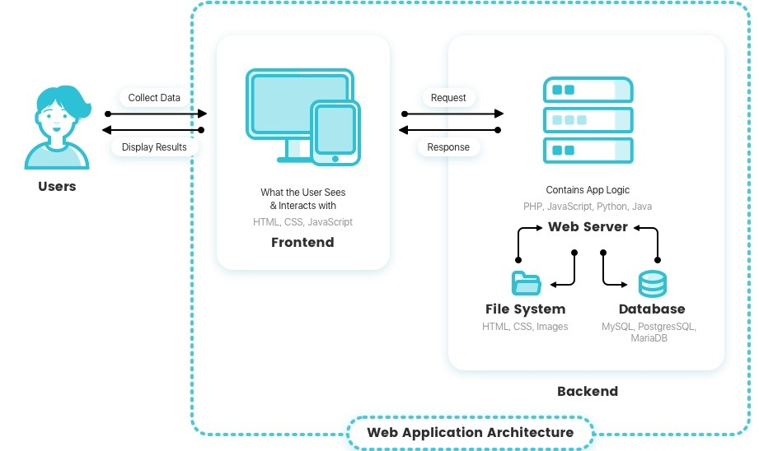

**4.2 UML DIAGRAMS**

**INTRODUCTION TO UML DIAGRAMS:**

A model is an abstract representation of a system, constructed to understand the system priority to build or modifying it. A model is a simplified representation of reality and it provides a means for conceptualization and communication of ideas in a precise and ambiguous form. We build models so that we can better understand the system we are developing. The elements are like components that can be associated in different ways to make a complete UML picture, which is known as a diagram. Thus, it is very important to understand the different diagrams to implement the knowledge in real-life systems. UML (Unified Modeling Language) is a standard language for specifying, visualizing, constructing, and documenting the artefacts of software systems. It is a method for describing the system architecture in detail using the blueprint. We use UML diagrams to portray the behaviour and structure of a system. This is the step while developing any product after analysis. The goal from this is to produce a model of the entities involved in the project which later need to be built. The representation of the entities that are to be used in the product being developed needs to be designed. There are various kinds of methods in software design:

• Use case Diagram

• Class Diagram

• Sequence Diagram

• Activity Diagram

• State Chart Diagram

**USECASE DIAGRAM**

This **Use Case Diagram** is a graphic depiction of the interactions among the elements of the **Small quizzes website**. It represents the methodology used in system analysis to identify, clarify, and organize the system requirements of the project.

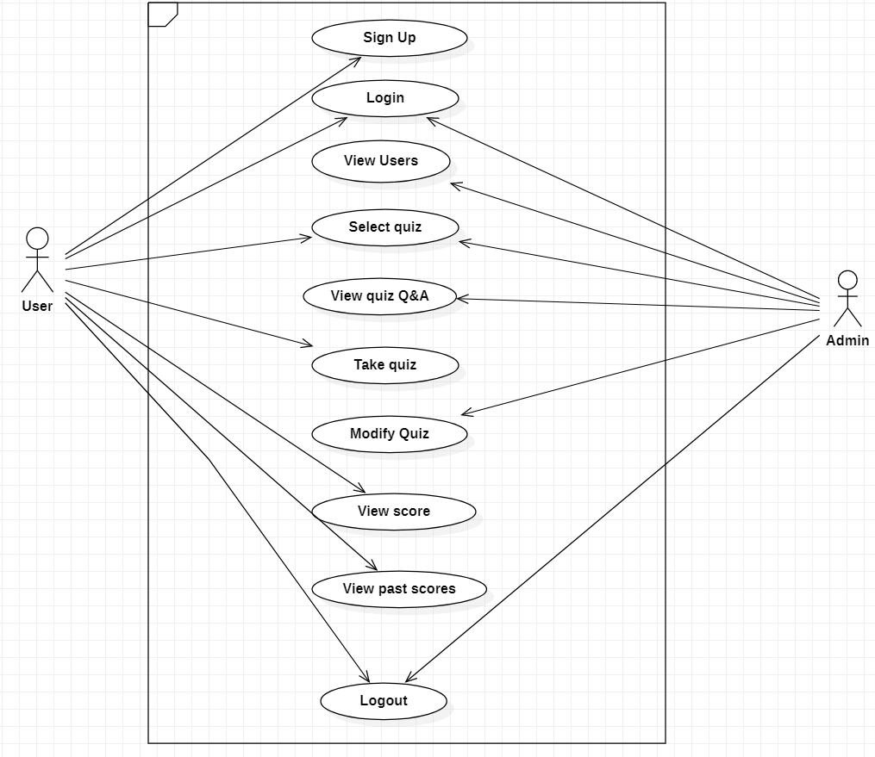

**SEQUENCE DIAGRAM**

A **sequence diagram** is a type of interaction **diagram** because it describes how—and in what order—a group of objects works together. ... **Sequence diagrams** are sometimes known as event **diagrams** or event scenarios.

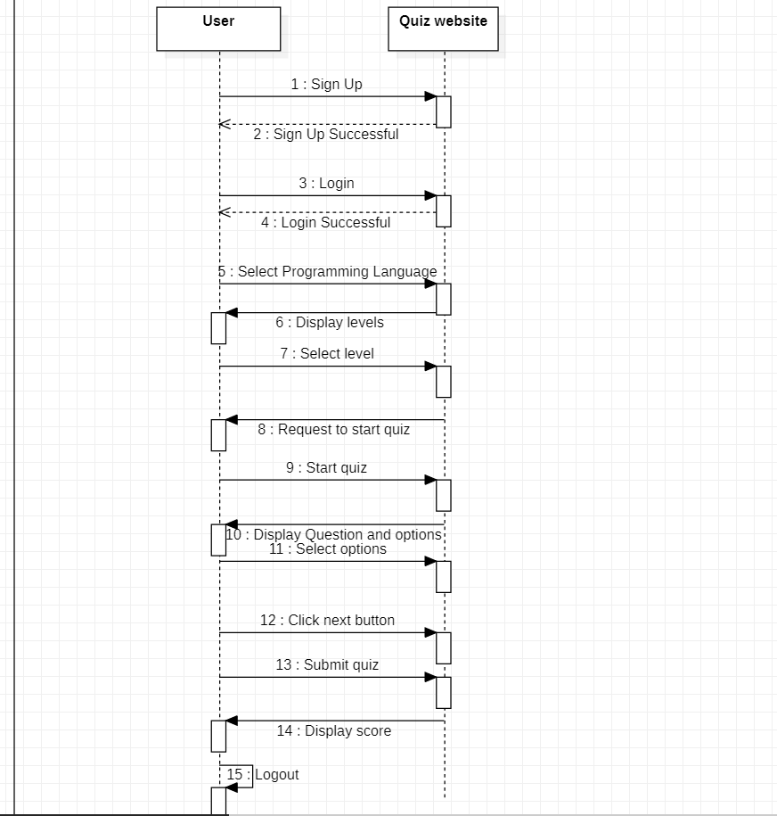

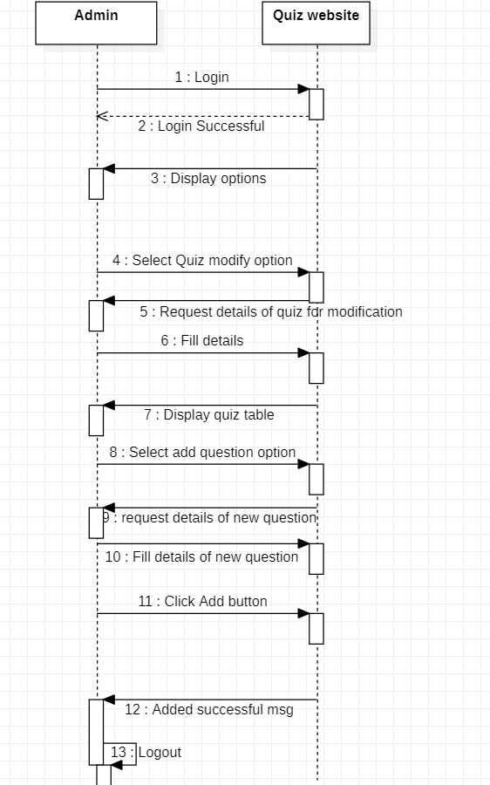

**STATE CHART DIAGRAM**

State chart diagram is one of the five UML diagrams used to model the dynamic nature of a system. They define different states of an object during its lifetime and these states are changed by events. State chart diagrams are useful to model the reactive systems. Reactive systems can be defined as a system that responds to external or internal events.

Statechart diagram describes the flow of control from one state to another state. States are defined as a condition in which an object exists and it changes when some event is triggered. The most important purpose of Statechart diagram is to model the lifetime of an object from creation to termination.

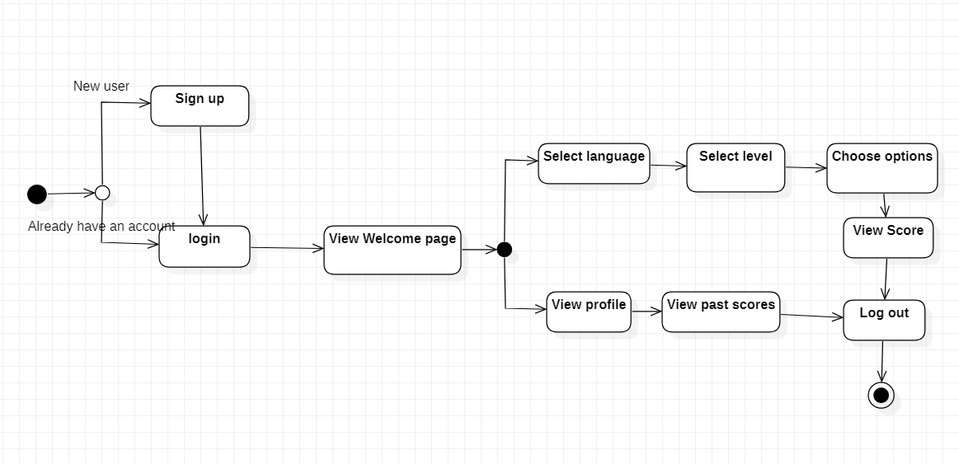

**CLASS DIAGRAM**

The class diagram is used to describe the models needed to build the application. There are ten classes, each of them has a relationship with one or more other classes. There are two types of relations:

1.Bi-directional association: This is used to show that the class is aware of the other class by adding a reference to the other class. The representation of this link is similar to the relationship between Order and Product.

2.Composition aggregation: This means that the class is part of the other class, the child cannot exist without the parent. The representation of this link is similar to the relationship between Restaurant and Opening (Figure 2). The arrow part points to the child, the other part points to the parent.

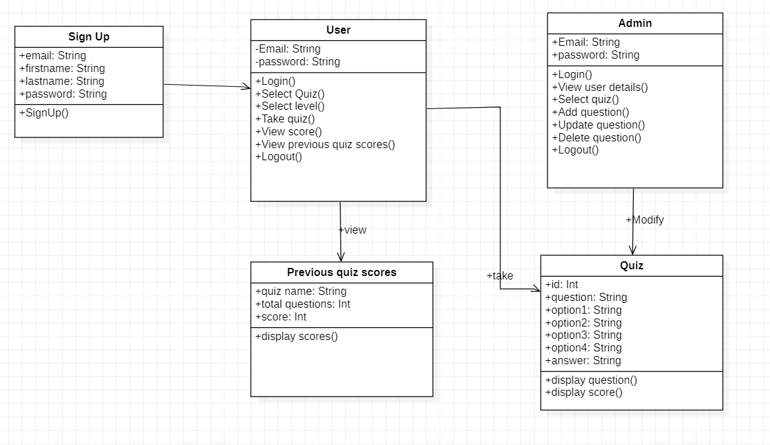

**5. SYSTEM IMPLEMENTATION**

**5.1 INTRODUCTION**

The purpose of system implementation can be summarized as follows: making the new System available to the prepared set of users (the deployment) , and positioning ongoing support and maintenance of the system within the performing organization (the Transaction). At a finer level necessary to educate the consumer on the use of the system, placing The newly developed system into production, confirming that business functions that Interact with the system and functioning properly. Transitioning the system support Responsibilities involve changing from system development to the system and Maintenance mode of operation, with ownership of the new system moving from the Project Team to the performing organization.

A key difference between system implementation and all other phases of the lifecycle is that All project activities up to this point have been performed in safe, protected and check environments. It is through the careful planning, execution and management of System implementation activities that the project team can minimize the likelihood of These occurrences and determine appropriate contingency plans in the event of the Problem.

In our system, a person can order food online by registering through their respective email id and password. So, it is secured and safe.

**5.2 PROJECT MODULES**

1. ADMIN MODULE
2. USER MODULE

**1. ADMIN MODULE:**

Login: Admin login into the website.

User info: View all details about users who have created accounts on the website.

Select quiz: Select quiz to make modifications.

Add questions: Add new questions to the selected quiz.

Edit question: Edit existing questions in the selected quiz.

Delete question: Delete existing questions from the selected quiz.

Logout: Logout from the website.

**2. USER MODULE:**

SignUp: If the user is new to the website he can sign up.

Login: User login into the website.

View Quizzes: View the quizzes available on the website.

Select quiz: Select the quiz and level of the quiz.

Start quiz: Start the selected quiz.

Choose an option: Choose the correct option for the question displayed on the page.

Click next: Click on the next button to get the next question.

View score: View the Score of the quiz.

View profile: View profile and past quiz scores.

Logout: Logout from the website.

**5.3 SCREENS:**

**Screens for User Module :**

**SignUp Page :**

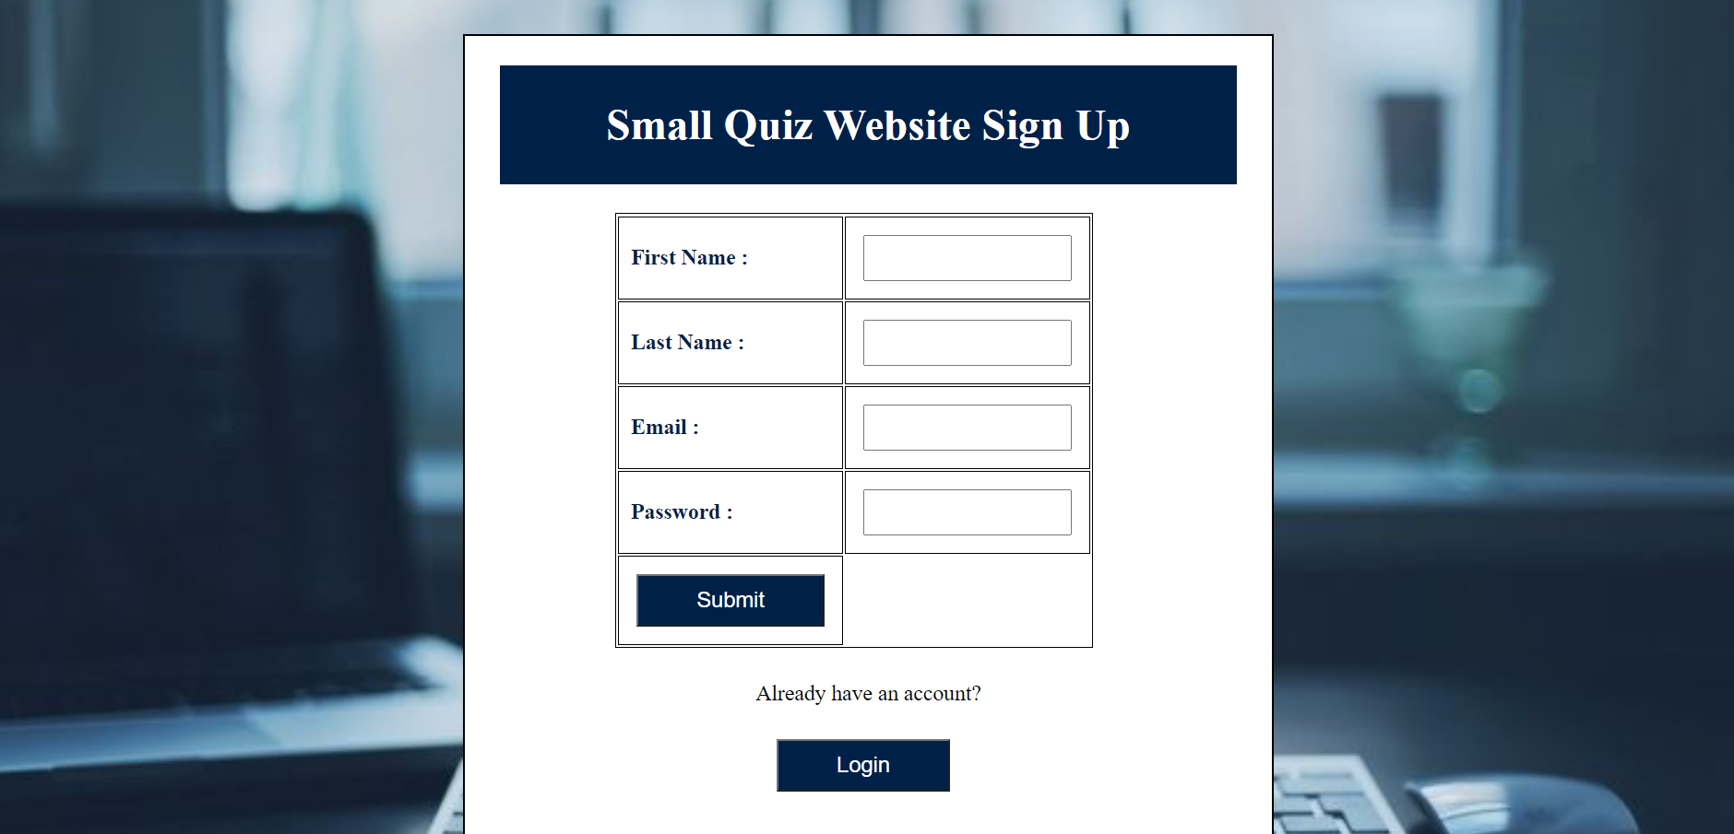

**Login Page :**

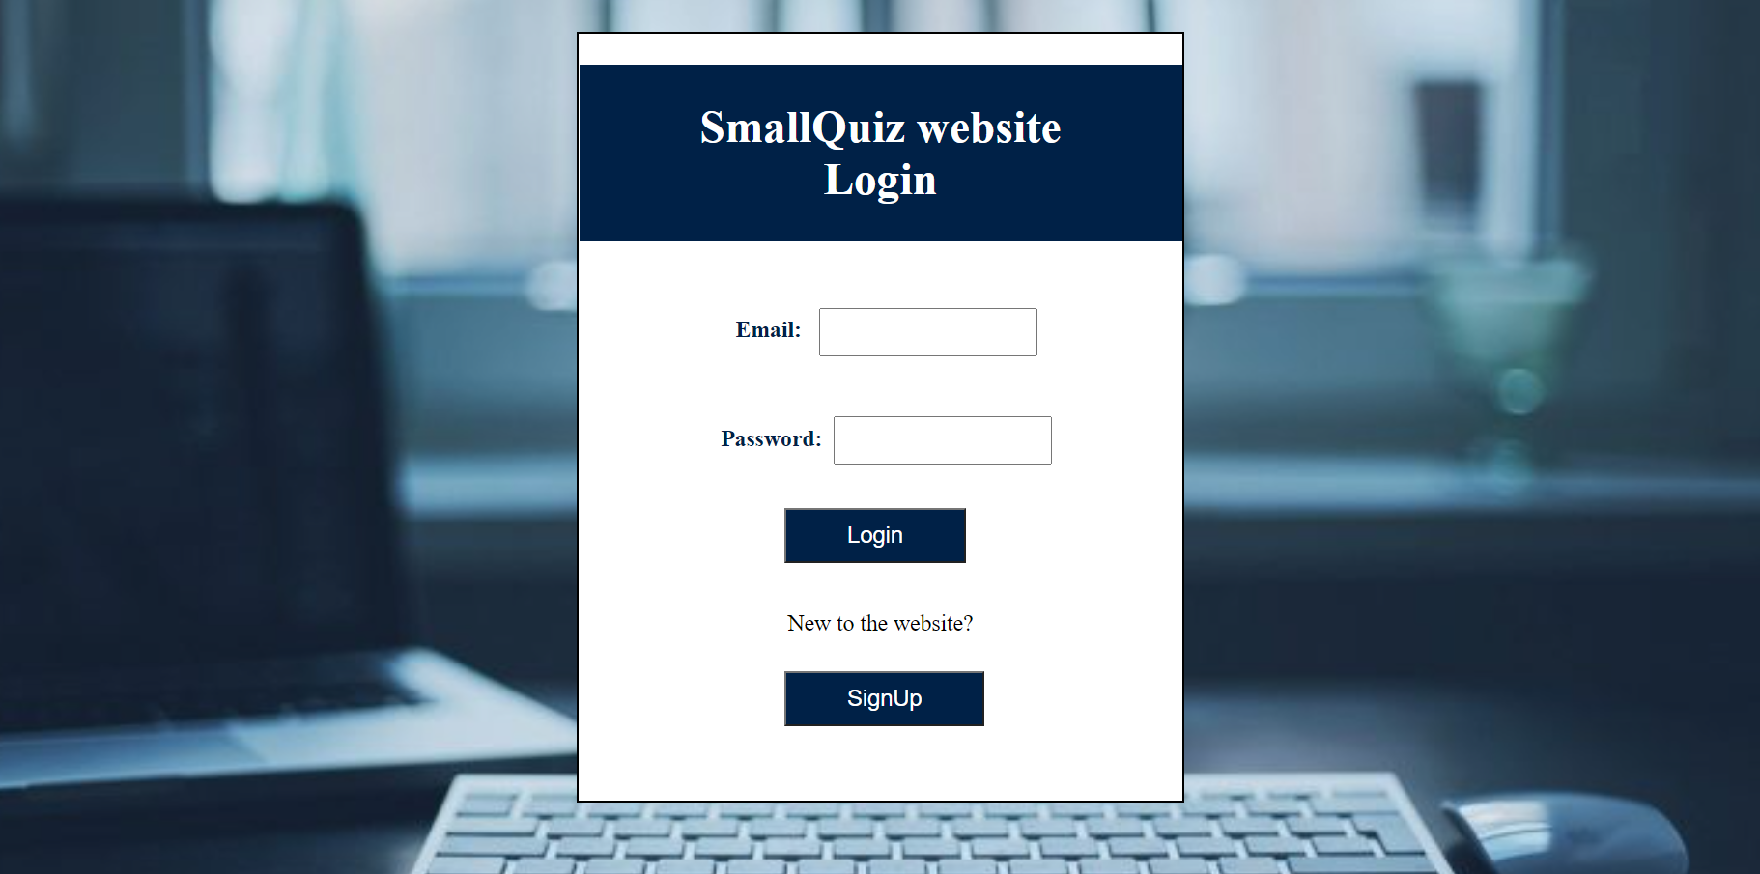

**Home / Welcome Page :**

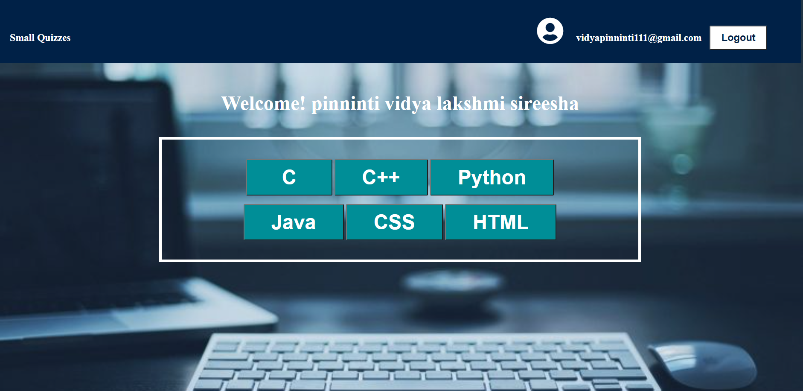

**C Language Quiz levels Page :**

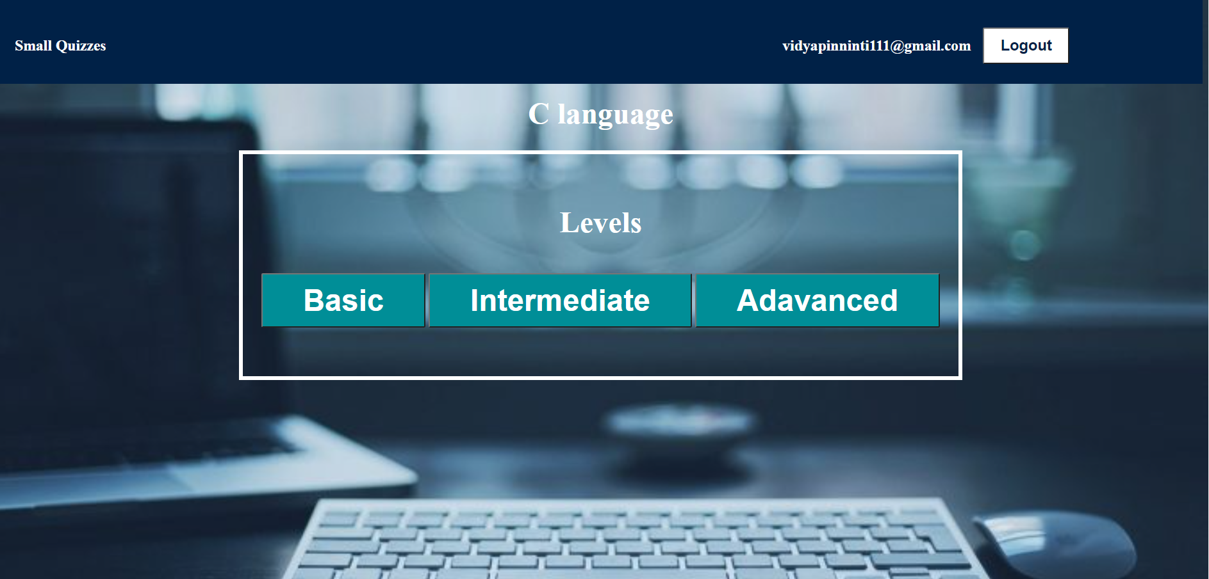

**C++ Quiz levels Page :**

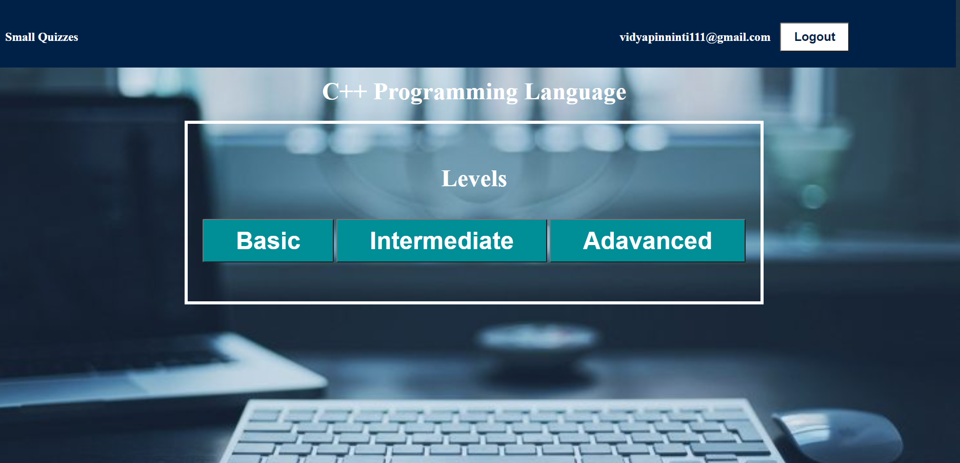

**Java Quiz Levels Page :**

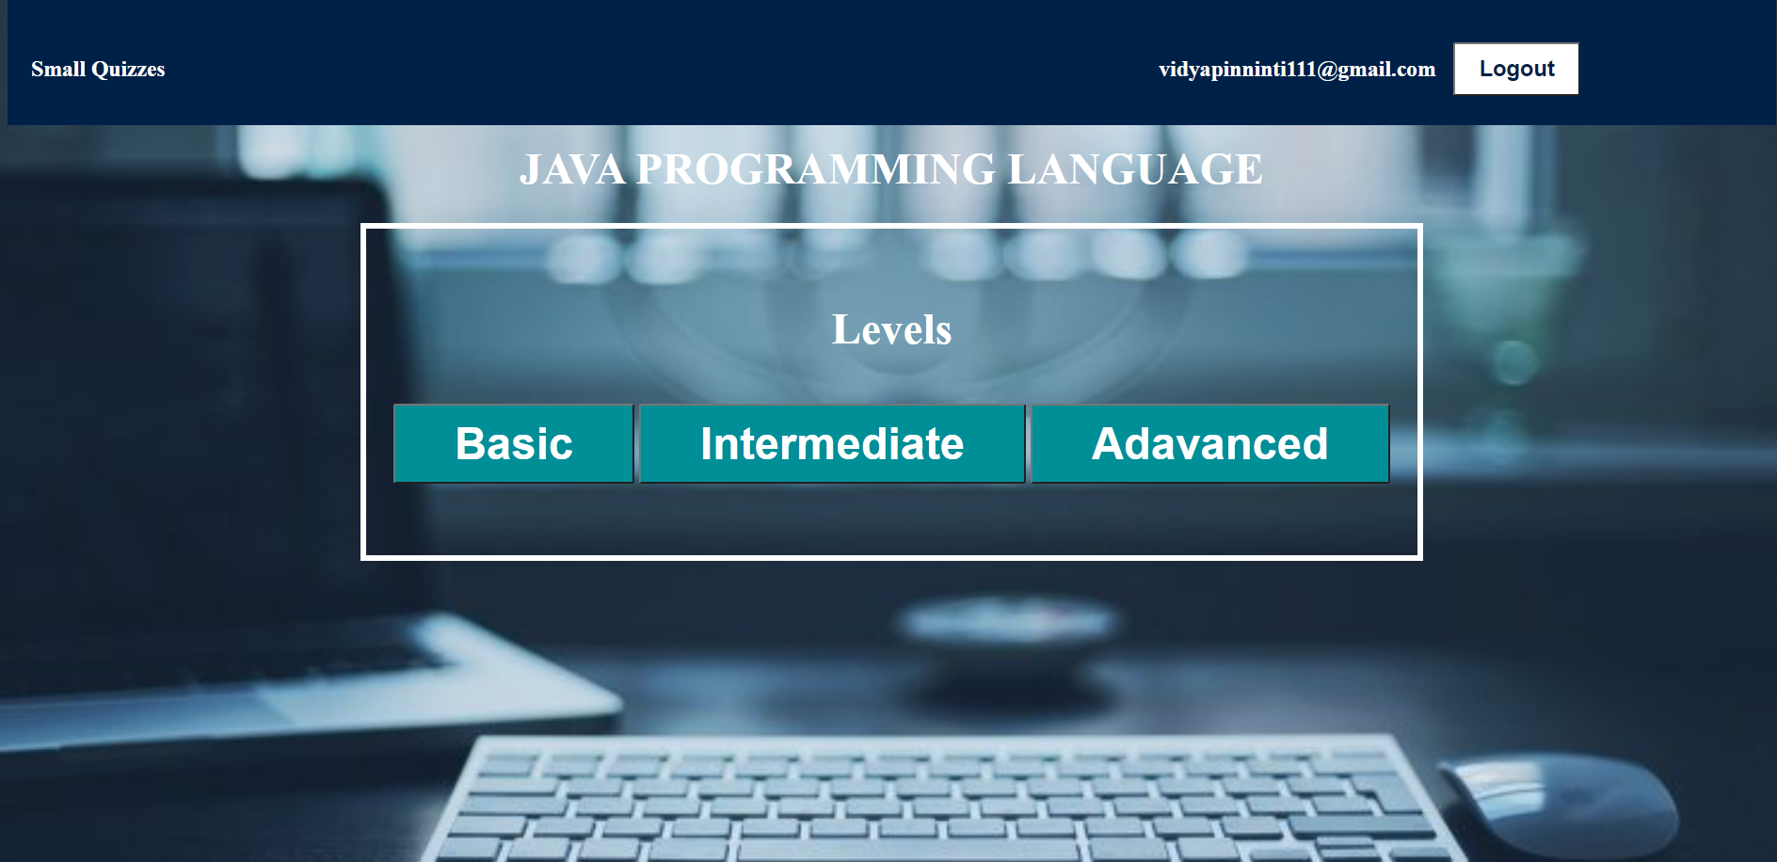

**HTML Quiz Levels Page:**

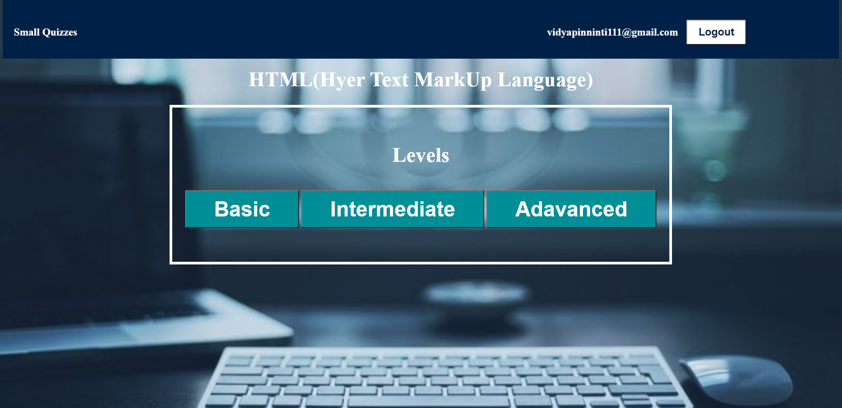

**CSS Quiz Levels Page :**

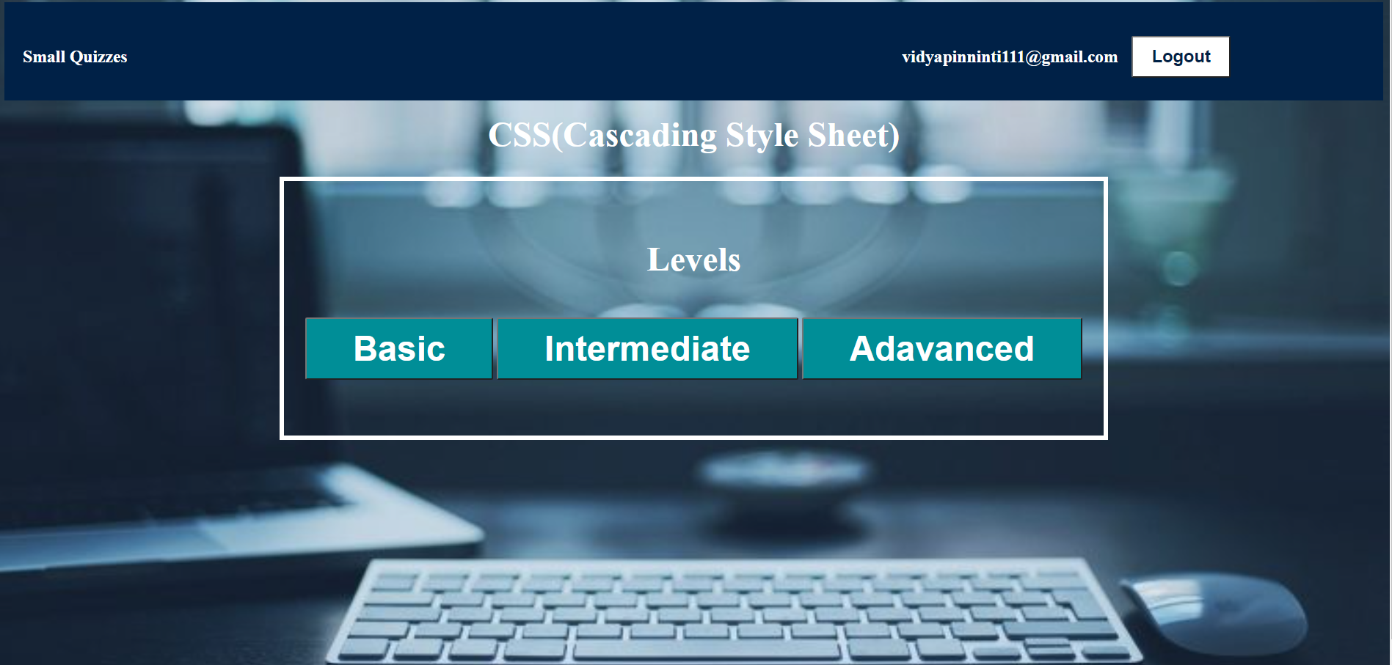

**Python Quiz Levels Page :**

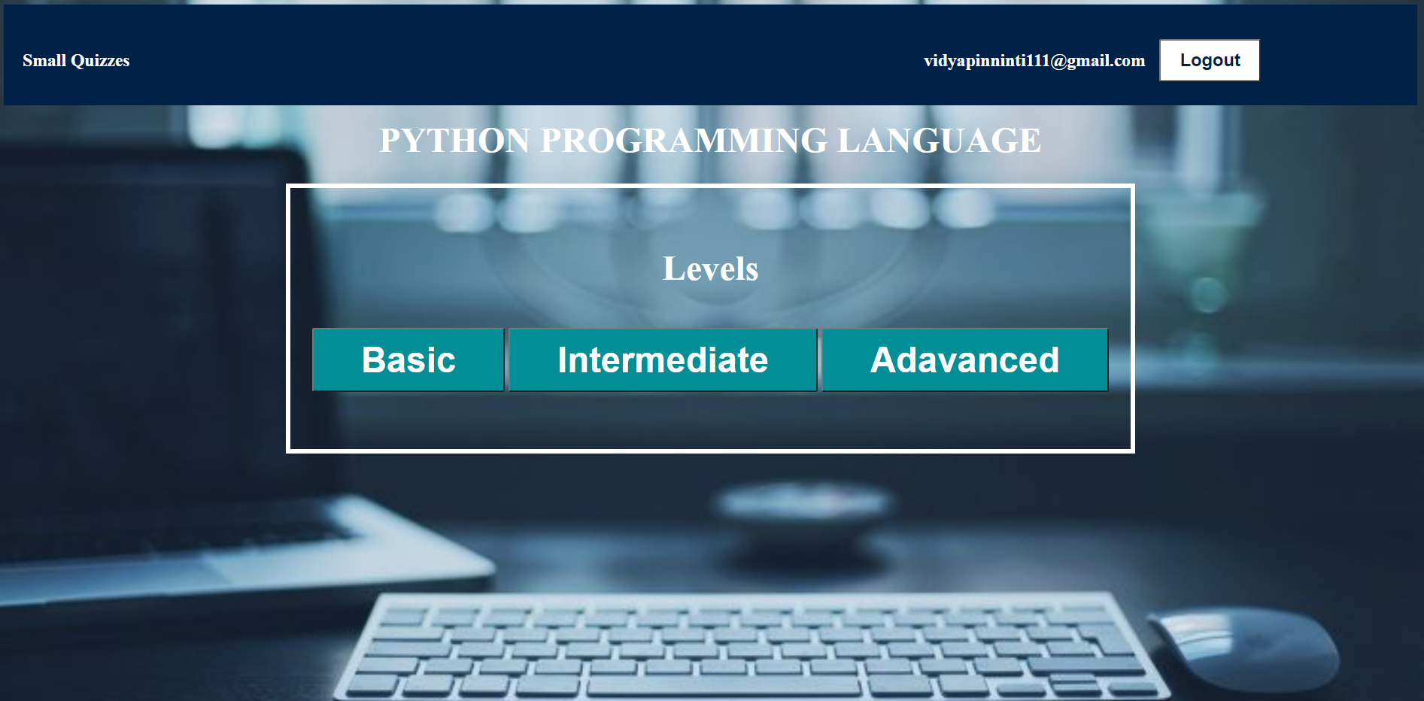

**Start Quiz Page :**



**Question Page :**



**Score Page :**



**Profile Page:**

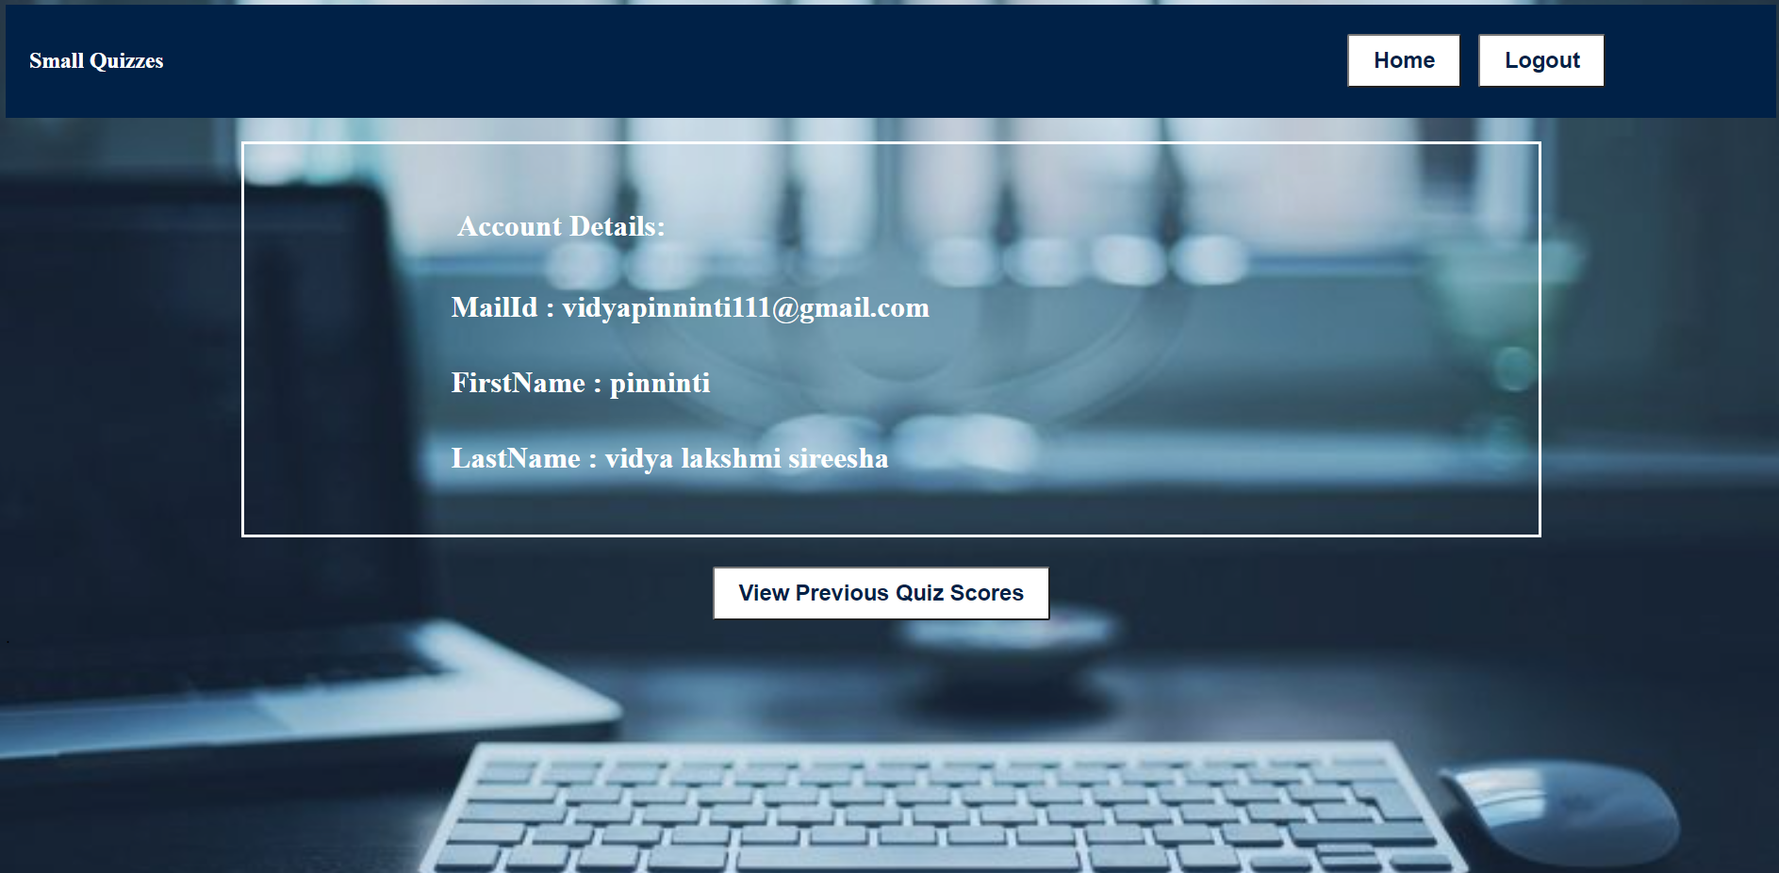

**Previous Scores Page :**



**Screens for Admin module :**

**Login Page :**

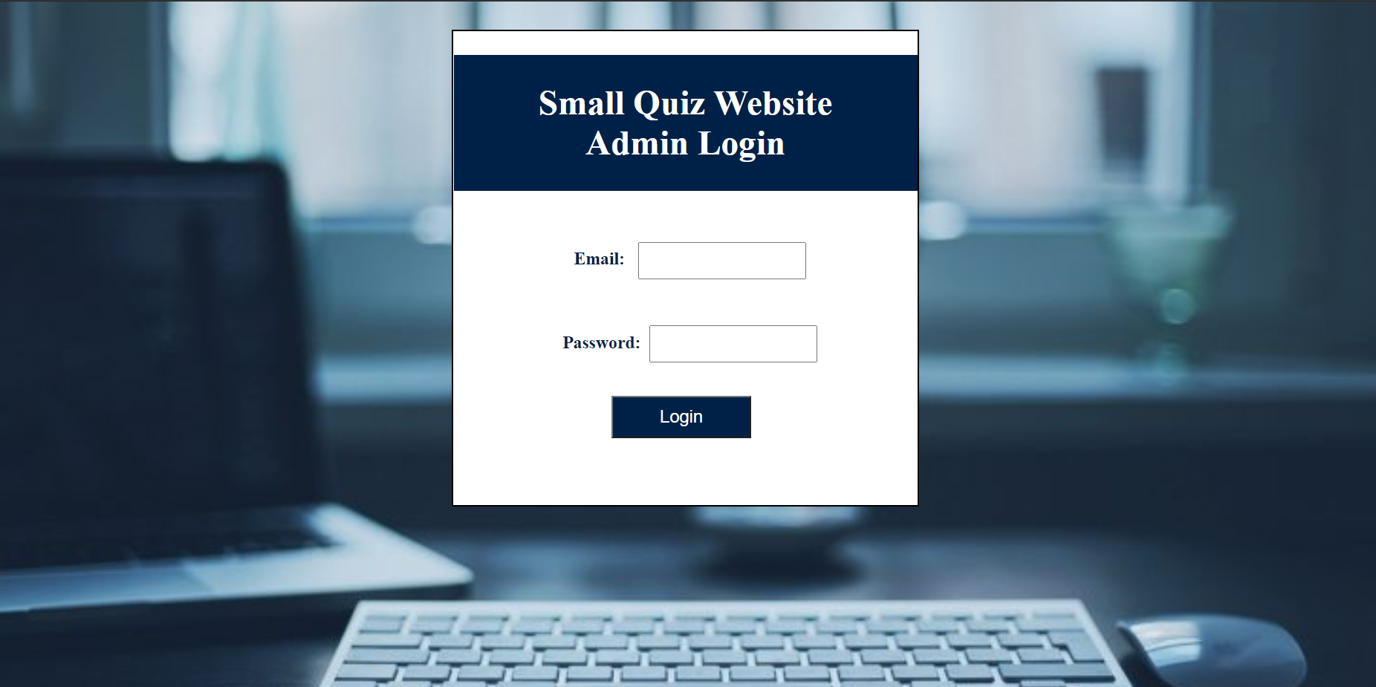

**Welcome / Home Page :**

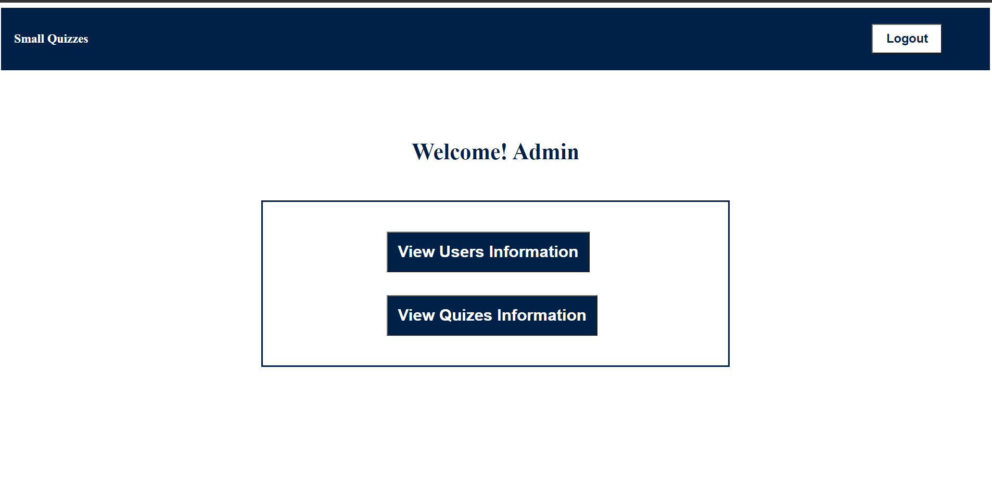

**User information Page :**

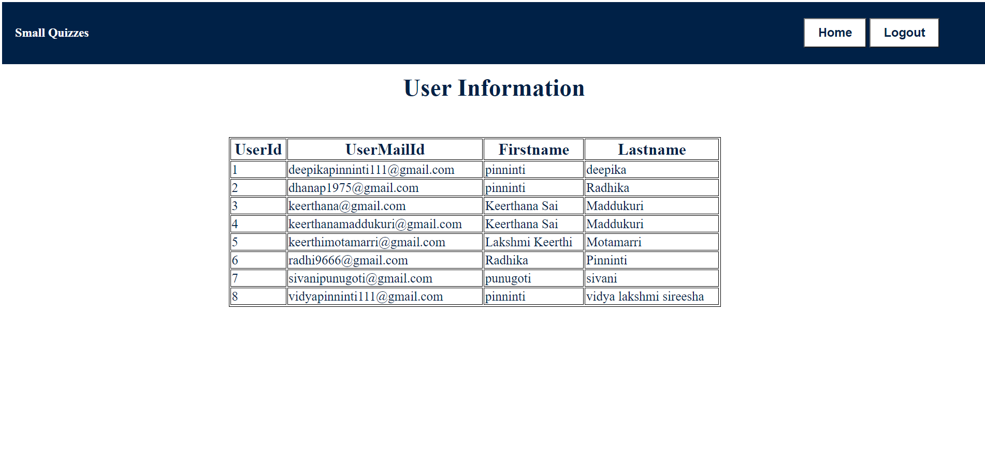

**Quiz Categories Page :**

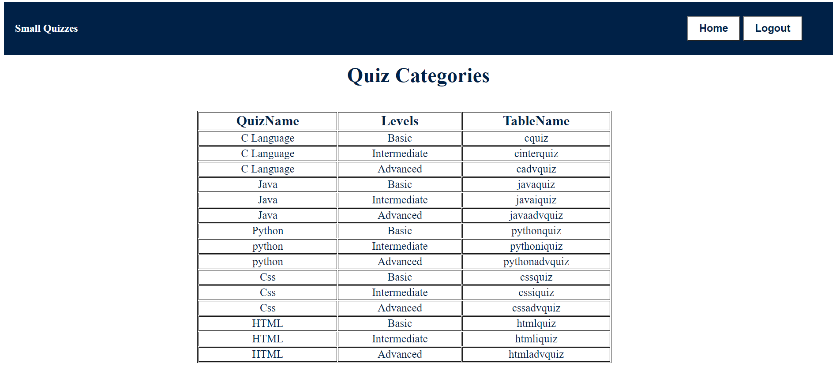

**Modifications Page :**

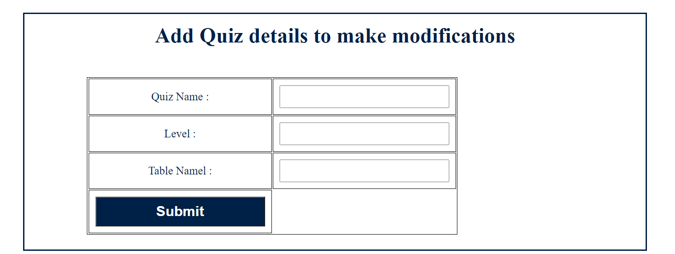

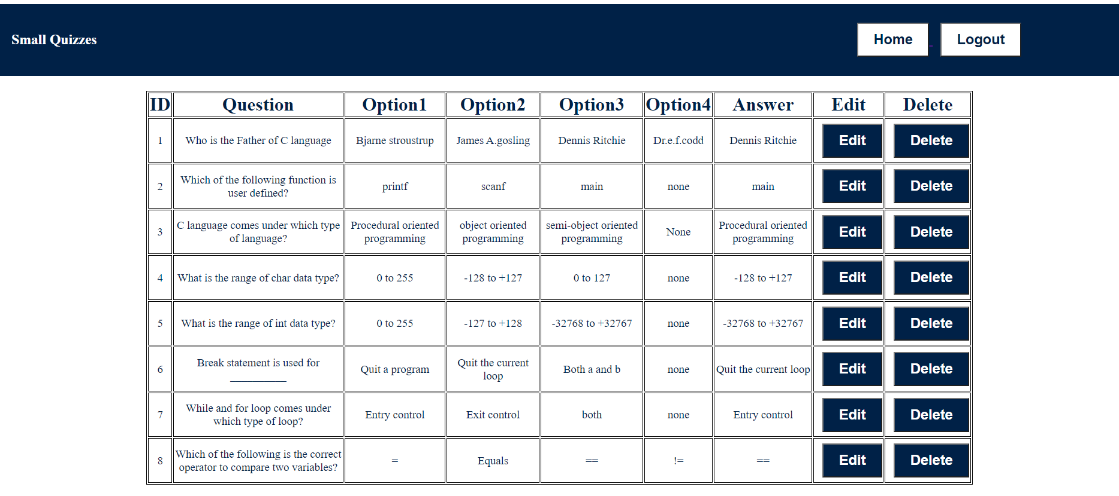

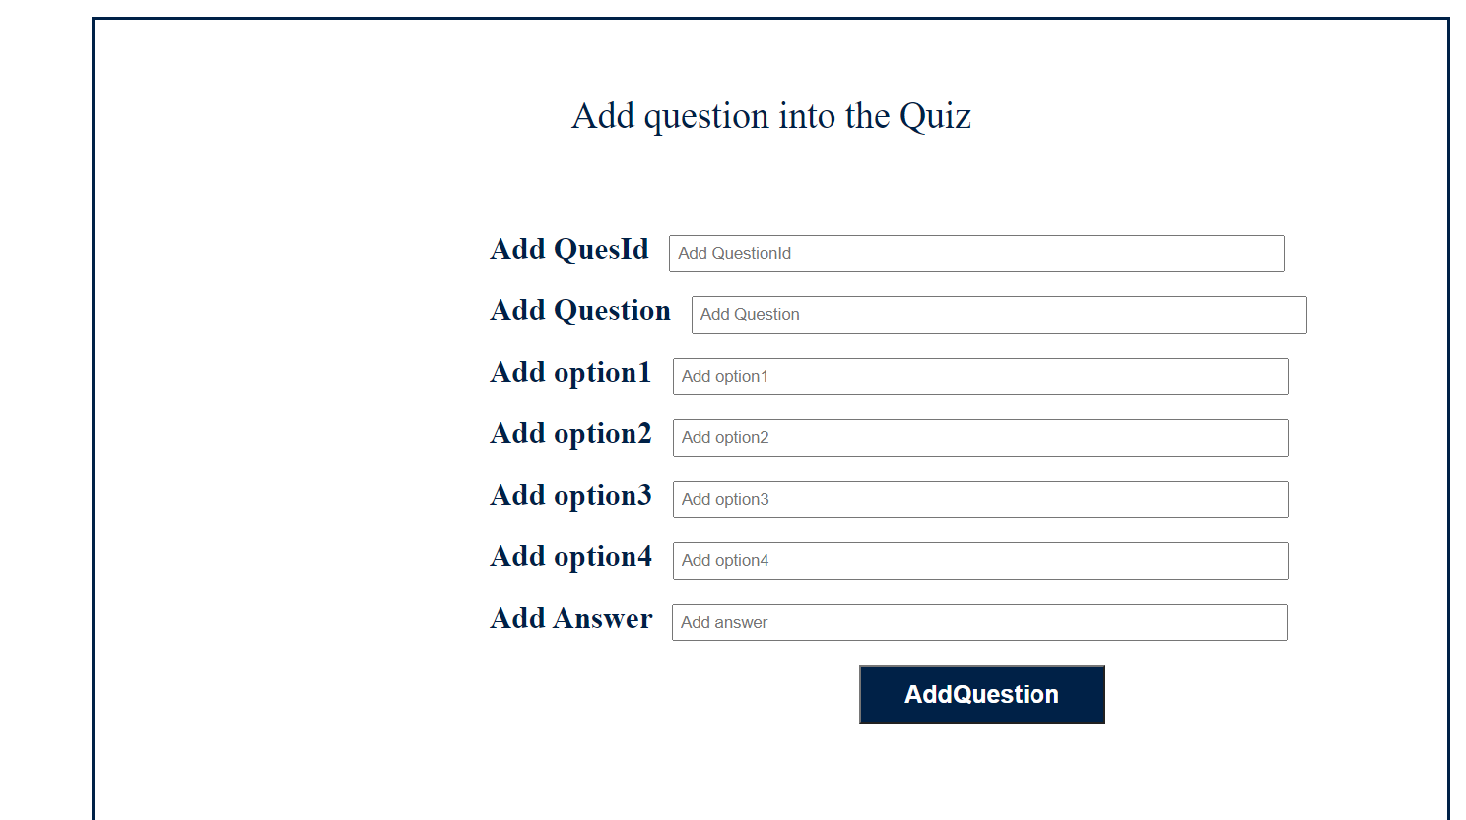

**6.TESTING**

**6.1 Introduction**

The purpose of testing is to discover the errors. Testing is the process of trying to discover every conceivable fault or weakness in a work product. It provides a way to check the functionality of components, subassemblies, assemblies and/or a finished product. It is the process of exercising software with the intent of ensuring that the software system meets its requirements and user expectations and does not fail in an unacceptable manner. There are various types of tests. Each test type addresses a specific testing requirement.

**6.2 Testing Methods**

Two main types of design testing are Black-box testing and White-box testing.

**Black-Box Testing**

In black-box testing, the internal logic of the system under testing is not considered and the test cases are decided from the specifications or the requirements. Equivalence class partitioning, boundary value analysis, and cause-effect graphing are examples of methods for selecting test cases for black-box testing. State-based testing is another approach in which the system is modelled as a state machine and then this model is used to select test cases using some transition or path-based coverage criteria. State-based testing can also be viewed as grey-box testing in that it often requires more information than just the requirements.

Some of the types of black-box testing are:

**Integration Testing**

Integration testing addresses the issues associated with the dual problems of verification and program construction. After the software has been integrated a set of high order tests are conducted. The main objective in this testing process is to take unit tested modules and builds a program structure that has been dictated by design.

Two types of integration testing are Top-down integration testing and Bottom-up integration testing.

**1.Top-Down Integration Testing**

This method is an incremental approach to the construction of program structure. Modules are integrated by moving downward through the control hierarchy, beginning with the main program module. The module subordinates to the main program module are incorporated into the structure in either a depth-first or breadth-first manner.

In this method, the software is tested from the main module and individual stubs are replaced when the test proceeds downwards.

**2.Bottom-up Integration Testing**

This method begins the construction and testing with the modules at the lowest level in the program structure. Since the modules are integrated from the bottom up, processing required for modules subordinate to a given level is always available and the

need for stubs is eliminated. The bottom-up integration strategy may be implemented with the following steps:

▪ The low-level modules are combined into clusters that perform a specific Software sub-function.

▪ A driver (i.e.) the control program for testing is written to coordinate test case input and output.

▪ The cluster is tested.

▪ Drivers are removed and clusters are combined moving upward in the program structure

The bottom-up approaches test each module individually and then each module is integrated with a main module and tested for functionality.

**System Testing**

Software once validated must be combined with other system elements (e.g. Hardware, people, database). System testing verifies that all the elements are proper and that overall system function performance is achieved. It also tests to find discrepancies between the system and its original objective, current specifications and system documentation.

**User Acceptance Testing**

User Acceptance of a system is the key factor for the success of any system. The system under consideration is tested for user acceptance by constantly keeping in touch with the prospective system users at the time of developing and making changes wherever required. The system developed provides a friendly user interface that can easily be understood even by a person who is new to the system.

**White-Box testing**

In white-box testing, the test cases are decided based on the internal logic of the program being tested. Often a criterion is specified, but the procedure for selecting test cases to satisfy the criteria is left to the tester. The most common criteria are statement coverage and branch coverage.

**Unit Testing**

Unit testing focuses verification effort on the smallest unit of Software design that is the module. Unit testing exercises specific paths in a module’s control structure to ensure complete coverage and maximum error detection. This test focuses on each module individually, ensuring that it functions properly as a unit. Hence, the naming is Unit Testing.

During this testing, each module is tested individually and the module interfaces are verified for consistency with the design specification. All important processing paths are tested for the expected results. All error handling paths are also tested.

**Validation Testing**

Validation checks are performed on the following fields.

Text Field:

The text field can contain only the number of characters lesser than or equal to its size. The text fields are alphanumeric in some tables and alphabetic in other tables. Incorrect entries always flash and error messages.

Numeric Field:

The numeric field can contain only numbers from 0 to 9. An entry of any character flashes an error message.

The individual modules are checked for accuracy and what it has to perform. Each module is subjected to a test run along with sample data. The individually tested modules are integrated into a single system. Testing involves executing the real data information used in the program the existence of any program defect is inferred from the output. The testing should be planned so that all the requirements are individually tested.

A successful test is one that gives out the defects for the inappropriate data and produces and output revealing the errors in the system.

**6.3 Test cases**

Test case design has to be done separately for each unit. Test case specification gives for each unit to be tested, all test cases, inputs to be used in the test cases, conditions being tested by the test case, and outputs expected for those test cases.A good test case design technique is crucial to improving the quality of the software testing process.  This helps to improve the overall quality and effectiveness of the released software.

Test case design refers to how you set-up your test cases. It is important that your tests are designed well, or you could fail to identify bugs and defects in your software during testing.

The following table shows the possible test case during:

1.Authentication

2.Data fetching from database

3.Access to questions or MCQ

4.Proper results for the user

5.User profile

6.Proper Logout

| Test Case Number | Test Case Description | Test Data | Expected Result | Actual Result | Pass/Fail |
| --- | --- | --- | --- | --- | --- |
| 1. | Check whether a message popped up without filling the password field in the Login page. | Clicking on the login button without filling in the password on the Login page. | Messages should be popped up saying the Password field is empty. | The message is popped up as ‘password field is empty | Pass |
| 2. | Check response if valid email-id and password are entered | Email :  19B01A05D0@svecw.edu.in  Password:  123456 | Login should be successful | Login was successful | Pass |
| 3. | Check response if either of email-id or password are not valid | Email:  19B01A05D0@svecw.edu.in  Password:  123567 | Login should not be successful | Login is not successful | Pass |
| 4. | Check if  giving email-id to sign-up which is already used | Email:  19B01A05D0@svecw.edu.in | Sign-up should not be successful | Sign-up is not successful | Pass |
| 5. | Check if after login the user’s mail and name are displayed correctly or not in the page. | For Sign Up:  FirstName : Vidya  LastName : Pinninti  Email:  19B01A05D5@svecw.edu.in  Password: 12345  For Login:  Email :  19B01A05D5@svecw.edu.in  Password:  12345 | After the profile icon on top, the Email should be [19B01A05D5@svecw.edu.in](mailto:19B01A05D5@svecw.edu.in)  Welcome! Vidya Pinninti | Email:  [19B01A05D5@svecw.edu.in](mailto:19B01A05D5@svecw.edu.in)  Welcome! Vidya Pinninti | Pass |
| 6. | Check whether clicking on the start button displaying  quiz questions or not. | Click on the start button | The first question of the quiz should be displayed which contains four options along with the next button. | The first question of the quiz is displayed which contains four options along with the next button. | Pass |
| 7. | Check by clicking on the next button by not selecting any option to the question | Click on the next button by not selecting any option. | Please select one of these options and a warning should be displayed. | Please select one of these options and a warning is displayed. | Pass |
| 8. | Check whether clicking on the next button gets the next question or not. | Click on the next button under the question in the quiz | Should get next question of the quiz | The next question of the quiz is displayed | Pass |
| 9. | Check whether clicking on the previous score button  Displaying previous quiz scores or not | Click on the previous score button in the profile | A table containing fields like Quiz name, Total No.of questions, Score should be displayed which contains information of all previous quizzes taken by the user. | A table containing fields like Quiz name, Total No.of questions, Score is displayed which contains information of all previous quizzes taken by the user. |  |
| 10. | Check whether Admin can view all the user information who have created an account on the website | Click on the user information button | The table of fields (Id , First name , Lastname,Email-ID) containing all the user information | The table of fields (Id , First name , Lastname ,Email-ID) containing all the user information | Pass |
| 11. | Check whether Admin can delete the question | Click on the delete button which is present in the 6th question’s row . | Question should be deleted from quiz table | Question is deleted from the quiz table | Pass |
| 12. | Check whether Id of the questions are updating or not when Admin deletes question from quiz | Click on the delete button which is present in the 6th question’s row. | Question Id of 7th question Id should be updated to 6 | Question Id of 7th question Id is updated to 6. | Pass |
| 13. | Check whether Admin can Add new question into the quiz | QuestionId:11  Question: QUESTION  Option1:1  Option2:2  Option3:3  Option4: 4 | Pop Up messages should be shown and Questions should be added to the quiz table | Pop Up message is shown and Question is added to the quiz table | Pass |
| 14. | Check if the user can log-out properly | Click log-out button | Logged out and return to the home page | Successfully logged out and returned to the home page | Pass |

Test case 1 :

Checking without filling the password field in the Login page.

Expected Result : Pop message Password field is empty.

Actual Result : Test Case Passed.

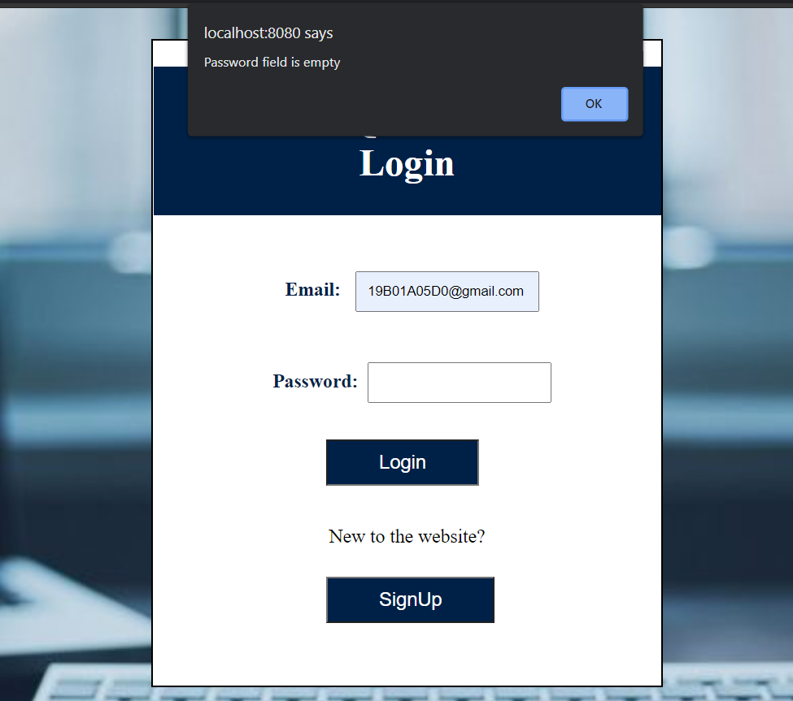

Test case 3:

Checking by giving wrong credentials in the login Page.

Expected result : Login is unsuccessful

Actual result : Test case passed.

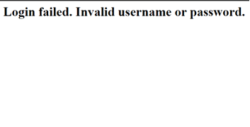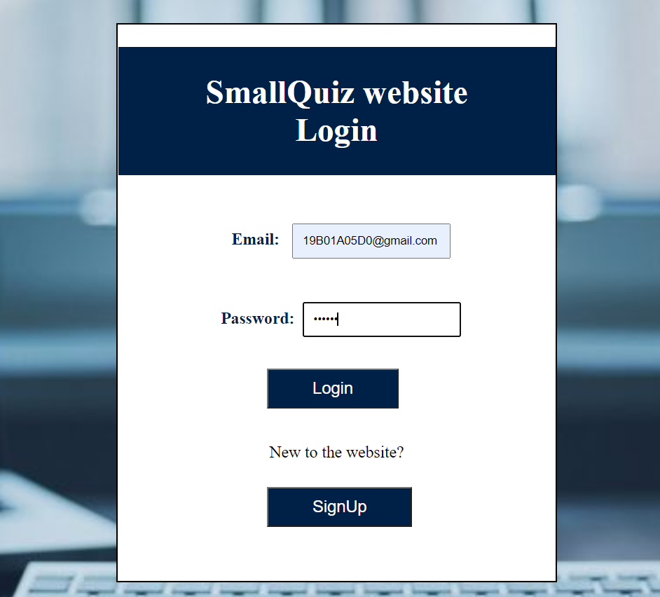

Test Case : 5

Check whether the name and mail of the user are correctly displayed in the Home page or not

Expected result :

Email-Id : [19B01A05D5@svecw.edu.in](mailto:19B01A05D5@svecw.edu.in) Which is beside the profile icon on top of the page

Welcome! Vidya Pinninti

Actual result : Test Case Passed

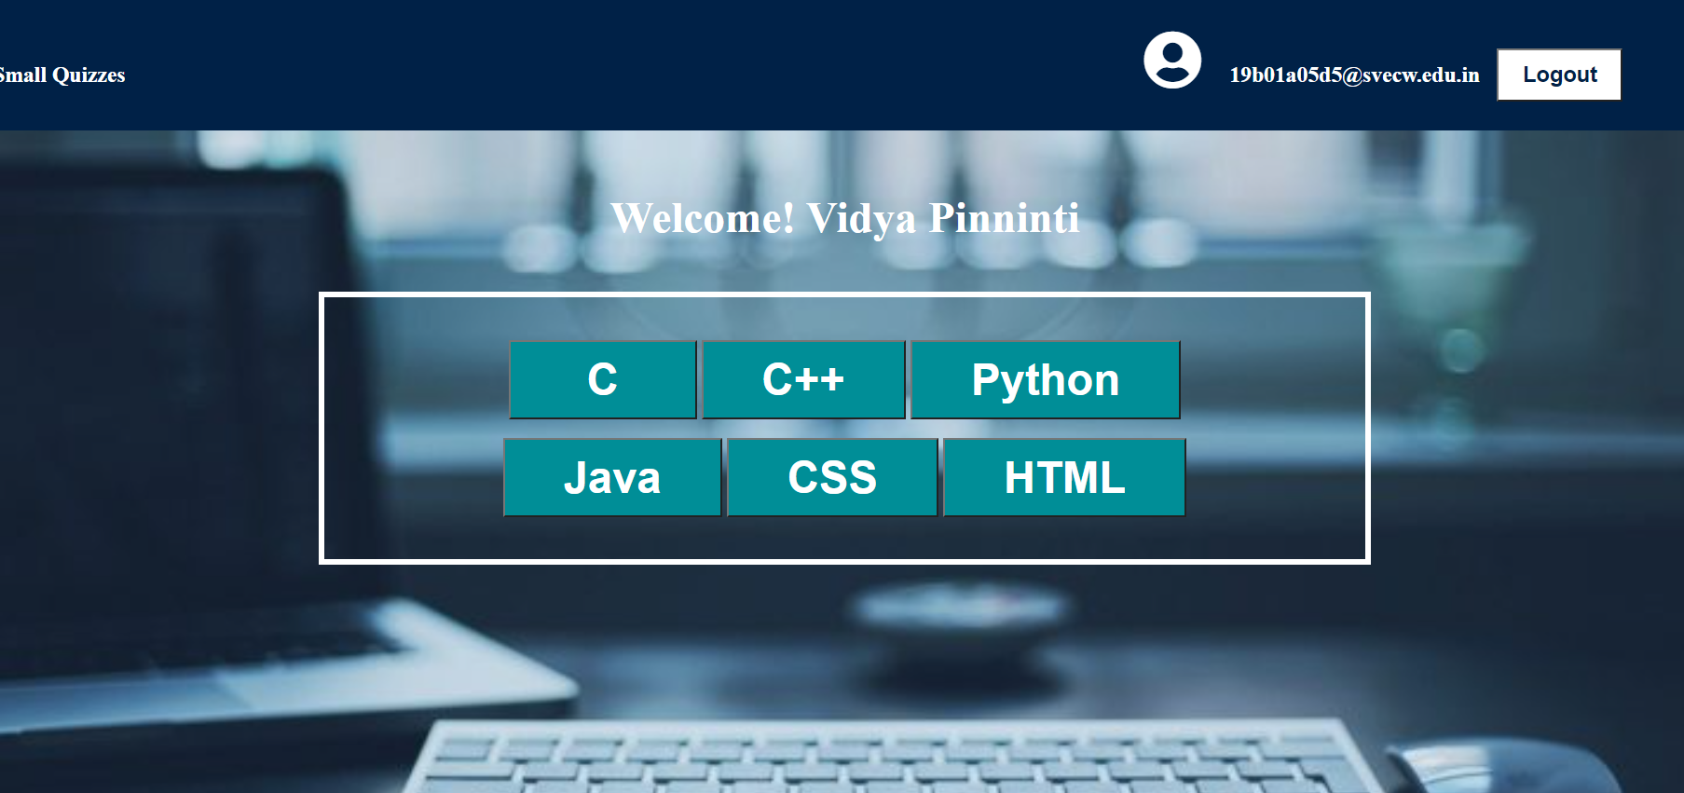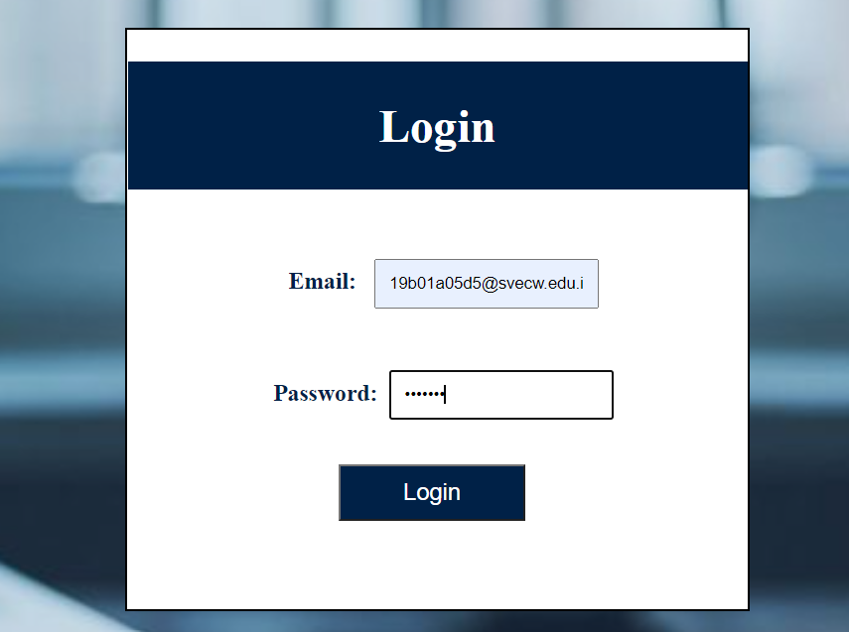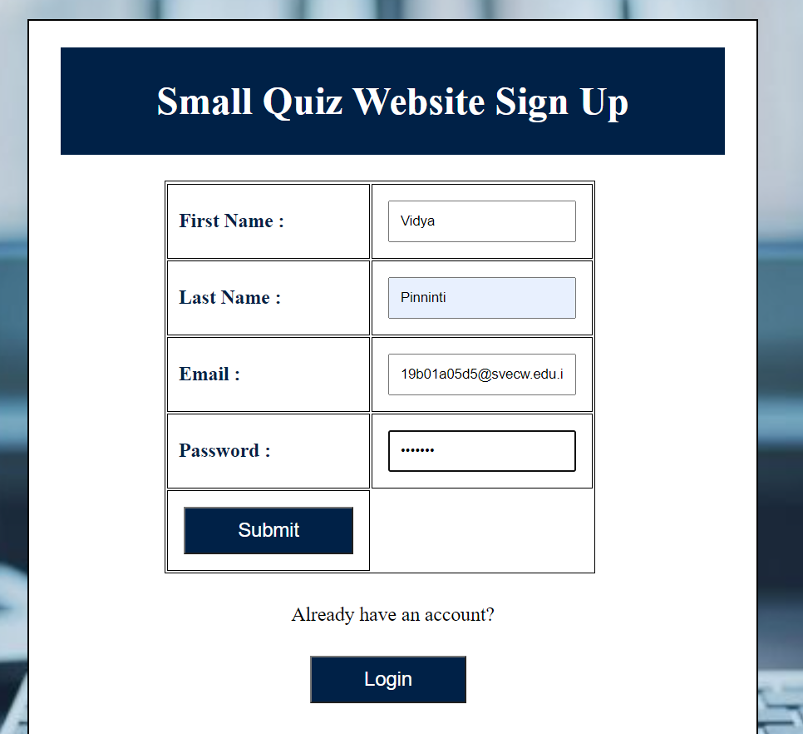

Test case 6:

Check whether clicking on start button displaying quiz question or not

Expected result : After clicking start quiz button first question of the quiz should be displayed

Actual result : Test Case passes



Test Case : 7

Check by clicking on next button without selecting any options.

Expected result : Please select one of these options like warning message should be displayed.

Actual result : Test case passed.

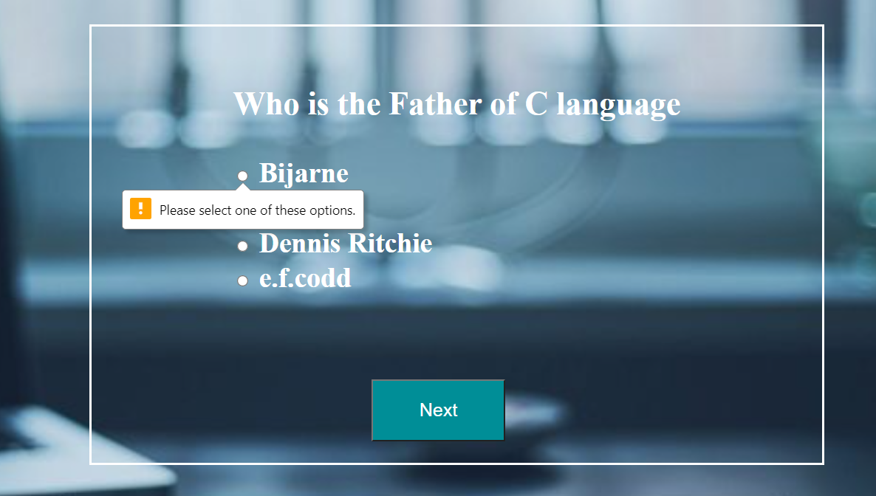

Test Case 10 :

Check whether Admin can view all the user information who have created account in the website

Expected result : The table of fields (UserId , UserMailId , First name , Lastname ) containing all the user information

Actual result : Test case passed.

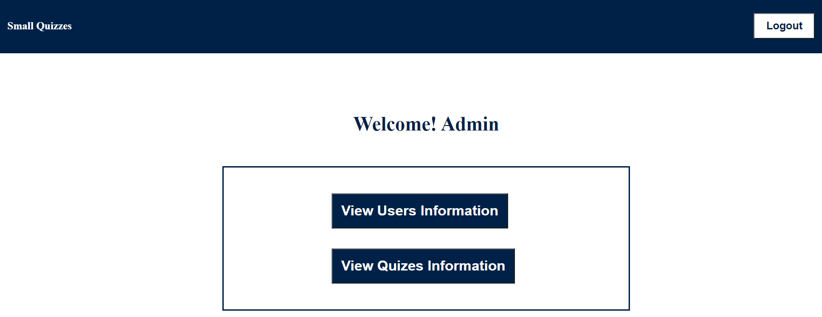

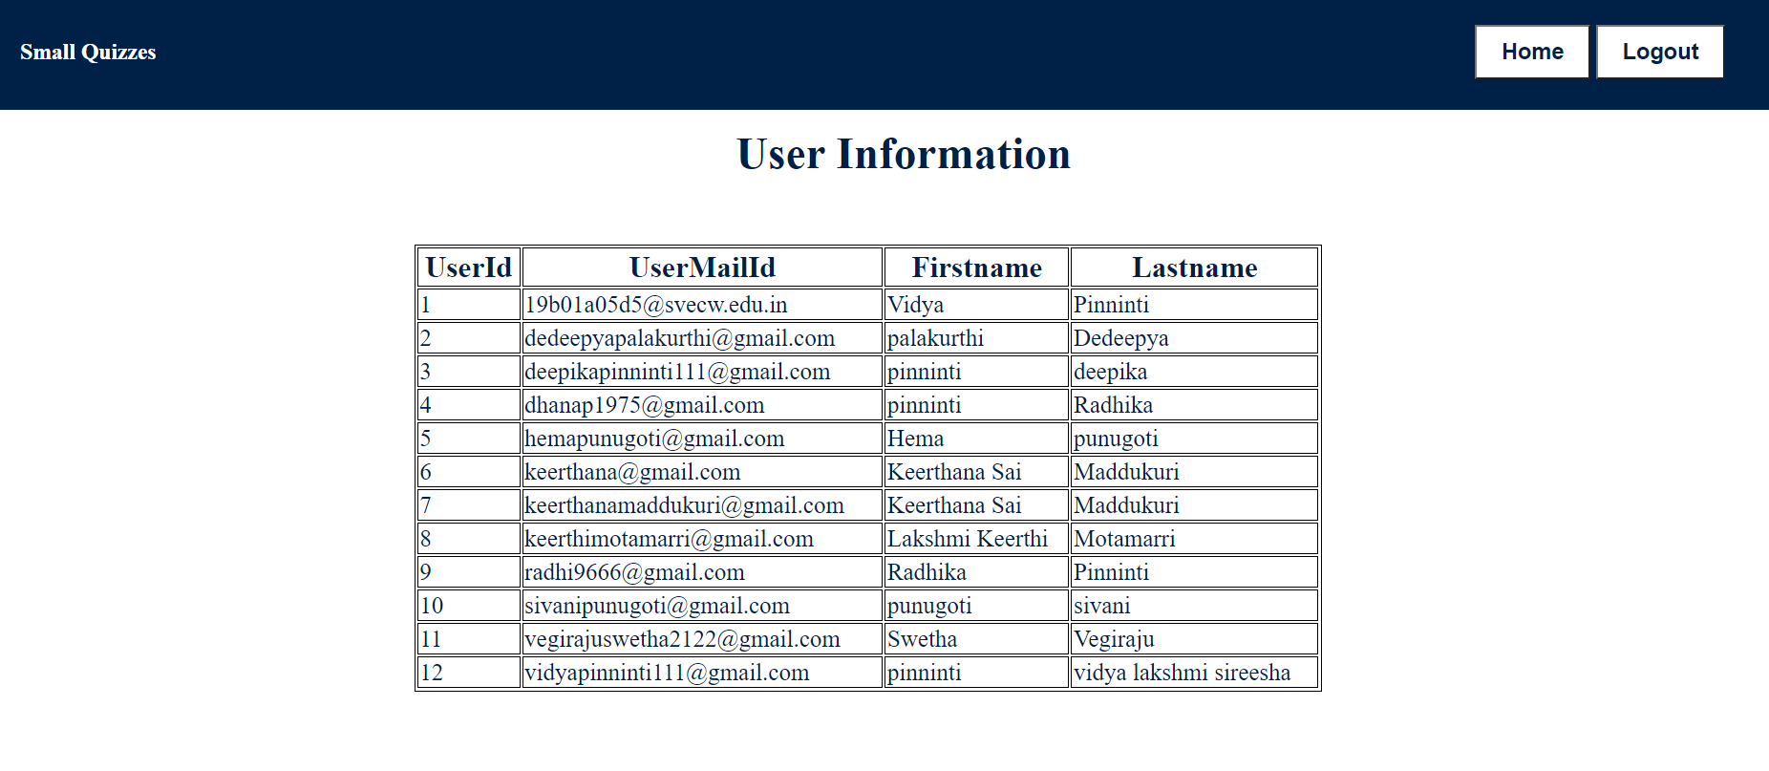

Test Case 11 :

Check whether Admin can delete the question from the quiz.

Expected result : Question should be deleted from the quiz table.

Actual result : Test Case passed.

Test Case 12 :

Check whether Id of the questions are updating or not when Admin deletes question from quiz.

Expected result : Question Id of 7th question Id should be updated to 6

Actual result : Test Case passed .

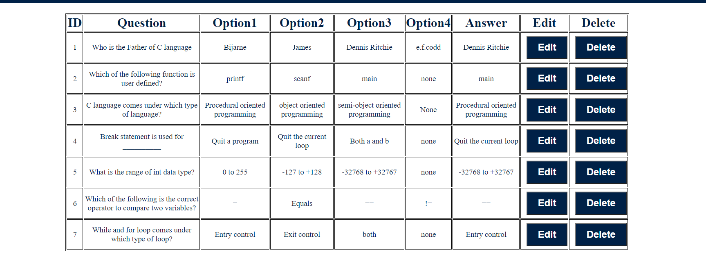

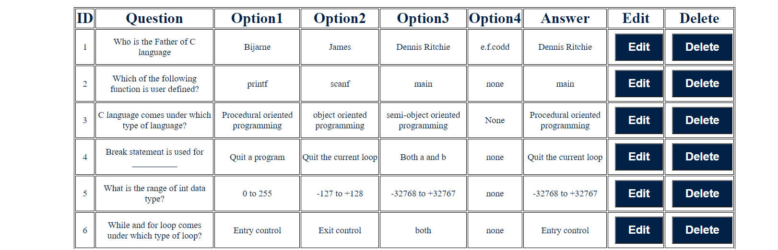

**7.CONCLUSION**

The main objective of the application is to help Computer Science students understand the basics of JavaScript, HTML,CSS and PHP.

And through this project, one can learn that a website can be created by using many effective ways such as xampp etc. The following results have been achieved after completing the system and relate back to the system’s objective.

**FUTURE WORKS:**

1.Forgot password: Users can click on the forgot password when they forgot the password.

2. Confirmation mail will be sent to the user's mail .

3. Users can change the details of the account like first name, last name, password.

4. Previous button will be provided in the quiz.

5. Timer will be set for the quiz.

7. After completion of the quiz the correct answers and description will be provided for each question in the quiz.

8. Admin can delete users if needed.

9. Admin can add new quizzes .

**8.BIBLIOGRAPHY**

<https://www.w3schools.com/html/>

<https://www.w3schools.com/html/html_css.asp>

**9. APPENDIX:**

**Introduction to HTML:**

HTML stands for HyperText Mark-up Language.

HTML is the standard mark-up language for creating Web pages.

HTML describes the structure of a web page. It consists of a series of elements.

HTML elements tell the browser how to display the content.

**Introduction to CSS:**

CSS stands for Cascading Style Sheets. CSS describes how HTML elements are to be displayed on screen, paper or in other media. CSS saves a lot of work. It can control the layout of multiple pages all at once. External style sheets are stored in CSS files. It is the language for describing the presentation of Web pages, including colours, layout and fonts thus making our web pages presentable to the users.

**Introduction to JavaScript:**

JavaScript is a lightweight, cross-platform, and interpreted scripting language .It is well-known for the development of web pages, and many non-browser environments also use it. JavaScript can be used for Client- side developments as well as Server-side developments. JavaScript contains a standard library of objects like array, date, and Math and a core set of language elements like operators, control structure and statements

**Introduction to PHP:**

Php is an acronym for "Hypertext Pre-processor". PHP is a widely -used, open source scripting language. PHP scripts are executed on the server. PHP is free to download and use.

**Introduction to MySQL:**

MySQL is a database system used for developing web-based software applications. It is used for both small and large applications. It is a relational database management system (RDBMS). MySQL is fast, reliable and easy to use. MySQL supports standard SQL (Structured Query Language). MySQL was developed by Michael Wide nous.

